|  |  |
| --- | --- |
| **Student Name** | **SRIRAMKUMAR M** |
| **Student Roll Number** | **921319104197** |
| **Maximum Marks** | **2 marks** |

**Assignment-3**

**1.Create a Bucket in IBM object storage.**

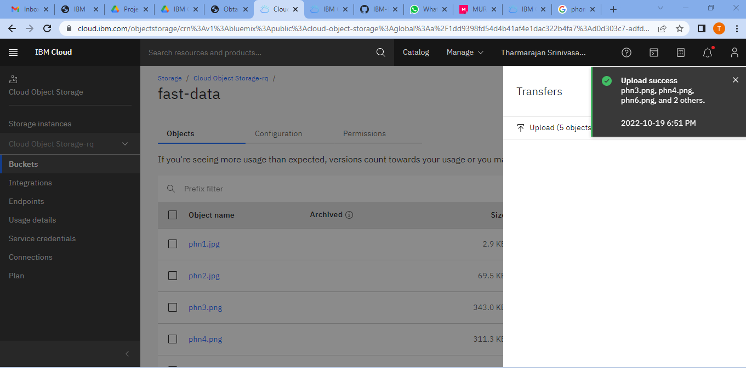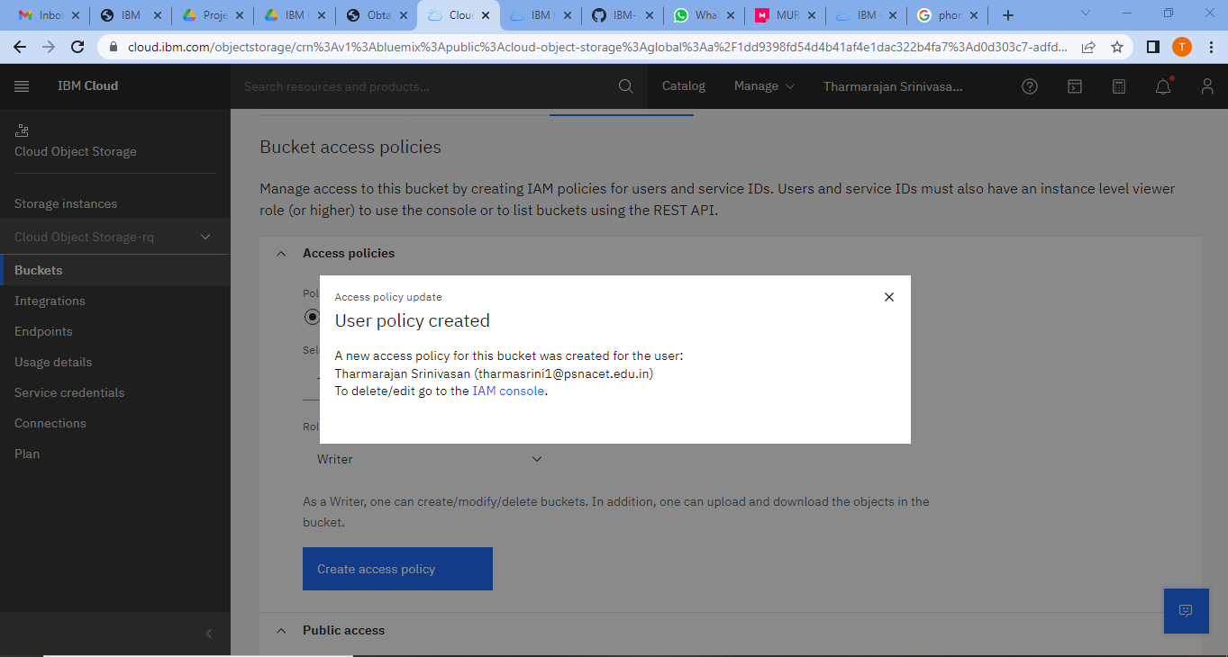

**2.Upload an 5 images to ibm object storage and make it public. write html code to displaying all the 5 images.**

**Source code:**

<!DOCTYPE html>

<html>

<head>

<title>

Images From Cloud Object Storage

</title>

<link rel="stylesheet" href="style.css">

</head>

<body>

<h2>Phone Images In Cloud Object Storage</h2>

<img src="https://fast-data.s3.jp-tok.cloud-object-storage.appdomain.cloud/phn1.jpg"></img>

<img src="https://fast-data.s3.jp-tok.cloud-object-storage.appdomain.cloud/phn2.jpg"></img>

<img src="https://fast-data.s3.jp-tok.cloud-object-storage.appdomain.cloud/phn3.png"></img>

<img src="https://fast-data.s3.jp-tok.cloud-object-storage.appdomain.cloud/phn4.png"></img>

<img src="https://fast-data.s3.jp-tok.cloud-object-storage.appdomain.cloud/phn6.png"></img>

</body>

</html>

**3.Upload a CSS page to the object storage and use the same page in your HTML code.**

**Source code:**

body {

font-family: 'Nunito', sans-serif;

color: #021233;

}

h2{

text-align: center;

}

img {

border-radius: 100px;

height: 250px;

width: 250px;

margin: 10px 100px 30px 20px;

background-color: rgb(187,190,189)

}

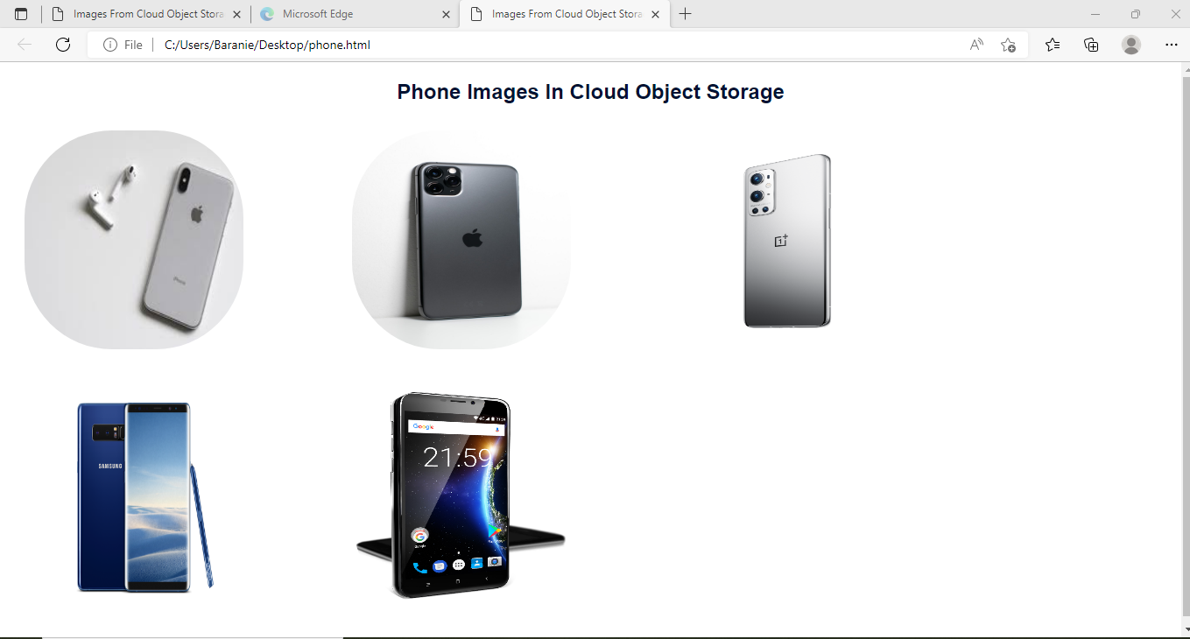

**4.Design a chatbot using IBM Watson assistant for hospital. Ex: User comes with query to know the branches for that hospital in your city. Submit the web URL of that chat bot as a assignment.**

**ChatBot Link :**

**<https://web-chat.global.assistant.watson.appdomain.cloud/preview.html?backgroundImageURL=https%3A%2F%2Fau-syd.assistant.watson.cloud.ibm.com%2Fpublic%2Fimages%2Fupx-84a95c8a-f77f-4a9f-9fe2-83c6c633eb73%3A%3Ad2c33b7c-8cb8-46b7-92cb-6882346edc04&integrationID=39b44b9b-ef19-4126-bf53-86fc28c4f6c4&region=au-syd&serviceInstanceID=84a95c8a-f77f-4a9f-9fe2-83c6c633eb73>**

**5.Create Watson assistant service with 10 steps and use 3 conditions in it. Load that script in HTML page.**

**Source code:**

<!DOCTYPE html>

<html>

<head>

<title>

IBM Watson ChatBot

</title>

<link rel="stylesheet" href="style.css">

<script>

window.watsonAssistantChatOptions = {

integrationID: "39b44b9b-ef19-4126-bf53-86fc28c4f6c4", // The ID of this integration.

region: "au-syd", // The region your integration is hosted in.

serviceInstanceID: "84a95c8a-f77f-4a9f-9fe2-83c6c633eb73", // The ID of your service instance.

onLoad: function(instance) { instance.render(); }

};

setTimeout(function(){

const t=document.createElement('script');

t.src="https://web-chat.global.assistant.watson.appdomain.cloud/versions/" + (window.watsonAssistantChatOptions.clientVersion || 'latest') + "/WatsonAssistantChatEntry.js";

document.head.appendChild(t);

});

</script>

</head>

<body>

<h1>ChatBot Page </h1>

</body>

</html>

